Placement Module

SUBMITTED IN PARTIAL FULFILLMENT FOR THE REQUIREMENT OF THE AWARD OF DEGREE OF

BACHELOR OF TECHNOLOGY
IN
COMPUTER SCIENCE



Submitted by

UJJWAL SONI (2100290120179)
AKASH PANDEY (2200290129003)
ADITYA NARAYAN YADAV (2200290129002)
PRAVEEN KUMAR YADAV (2200290129014)

PROF.ANURAG MISHRA
(Assistant Professor)
Session 2024-25

DEPARTMENT OF COMPUTER SCIENCE
KIET GROUP OF INSTITUTIONS, GHAZIABAD
(Affiliated to Dr. A. P. J. Abdul Kalam Technical University, Lucknow, U.P., India)
May 2025

TABLE OF CONTENTS | Page No.
DECLARATION……………………………………………………………………. | ii
CERTIFICATE……………………………………………………………………… | iii
ACKNOWLEDGEMENTS…………………………………………………………. | iv
ABSTRACT……………………………………………………………………….... | v
LIST OF FIGURES…………………………………………………………………. | ix
LIST OF TABLES…………………………………………………………………… | xi
LIST OF ABBREVIATIONS………………………………………………………. | xii
SDG MAPPING WITH JUSTIFICATION ………………………………………. | xii
CHAPTER 1 INTRODUCTION
1.1 Introduction to Project
1.2 Project Category
1.3 Objectives
1.4 Structure of Report

CHAPTER 2 LITERATURE REVIEW
2.1 Literature Review
2.2 Research Gaps
2.3 Problem Formulation

CHAPTER 3 PROPOSED SYSTEM
3.1 Proposed System
3.2 Unique Features of The System

CHAPTER 4 REQUIREMENT ANALYSIS AND SYSTEM SPECIFICATION
4.1 Feasibility Study (Technical, Economical, Operational)
4.2 Software Requirement Specification
4.2.1 Data Requirement
4.2.2 Functional Requirement
4.2.3 Performance Requirement
4.2.4 Maintainability Requirement
4.2.5 Security Requirement
4.3 SDLC Model Used
4.4 System Design
4.4.1 Data Flow Diagrams
4.4.2 Use Case Diagrams
4.5 Database Design

CHAPTER 5 IMPLEMENTATION
5.1 Introduction Tools and Technologies Used.
5.2 Dataset Description (IF ML based project)

CHAPTER 6 TESTING, AND MAINTENANCE
6.1 Testing Techniques and Test Cases Used

CHAPTER 7 RESULTS AND DISCUSSIONS
7.1 Description of Modules with Snapshots
7.2 Key findings of the project
7.3 Brief Description of Database with Snapshots
OR (for ML Based projects use below points)
7.1 Presentation of Results (Charts/Graphs/Tables)
7.2 Performance Evaluation
7.3 Key Findings

CHAPTER 8 CONCLUSION AND FUTURE SCOPE
REFERENCES (Only in IEEE FORMAT)
Research Paper Acceptance Proof
4Research Paper (If Presented/ Published)
Proof of patent publication (Screenshot of Publication)

DECLARATION
We hereby declare that this submission is our own work and that, to the best of our knowledge and belief, it contains no material previously published or written by another person nor material which to a substantial extent has been accepted for the award of any other degree or diploma of the university or other institute of higher learning, except where due acknowledgment has been made in the text.

Signature
Name:- AKASH PANDEY
Roll No.:- 2200290129003
Date:-03/03/2025

CERTIFICATE

This is to certify that Project Report entitled Placement Module which is submitted by Akash Pandey, Aditya Narayan Yadav, Praveen Kumar Yadav, Ujjwal Soni in partial fulfillment of the requirement for the award of degree B. Tech. in Department of Computer Science of Dr. A.P.J. Abdul Kalam Technical University, Lucknow is a record of the candidates own work carried out by them under my supervision. The matter embodied in this report is original and has not been submitted for the award of any other degree.

Date: 03/03/2025 Supervisor: Prof. ANURAG MISHRA
Name Dr. Ajay Kumar Shrivastava
Head of Department

ACKNOWLEDGEMENT

It gives us a great sense of pleasure to present the report of the B. Tech Project undertaken during B. Tech. Final Year. We owe special debt of gratitude to Professor Prof.Anurag Mishra Department of Computer Science, KIET, Ghaziabad, for his/her constant support and guidance throughout the course of our work. His/Her sincerity, thoroughness and perseverance have been a constant source of inspiration for us. It is only his cognizant efforts that our endeavors have seen light of the day.
We also take the opportunity to acknowledge the contribution of Dr. Ajay Kumar Shrivastava, Head of the Department of Computer Science, KIET, Ghaziabad, for his full support and assistance during the development of the project. We also do not like to miss the opportunity to acknowledge the contribution of all the faculty members of the department for their kind assistance and cooperation during the development of our project.
Last but not the least, we acknowledge our friends for their contribution in the completion of the project.
Date: 03/03/2025
Signature:
Name : AKASH PANDEY
Roll No.: 2200290129003

ABSTRACT

The Placement Module is a full-fledged web-based application that will automate and make campus recruitment smoother, with ease of interaction between the recruiters, placement coordinators, and students. The project focuses on enhancing the efficiency of placement activities like job postings, student applications, interview scheduling, and result tracking. It is built with current web technologies such as HTML, CSS, JavaScript, Bootstrap, and Tailwind CSS on the frontend and Node.js, Express.js, SQL, and REST APIs on the backend. The system provides a seamless user experience and interactive interface to all users on board.

The major functionalities of the module include secure user log-in, real-time reminders and notifications, a centralized database to control student records and job postings, and end-to-end traceability of application status. These features assist in minimizing manual administrative work, closing communication gaps, and maintaining transparency across the recruitment cycle. The module facilitates placement coordinators to work with huge amounts of data with ease and enables students to remain updated with opportunities and their status. Recruiters can access candidate details and arrange interviews in an efficient manner. In total, the Placement Module boosts coordination, conserves time, and streamlines recruitment management, ultimately providing an enhanced and better-organized placement experience for educational institutions and hiring organizations alike.

LIST OF FIGURES
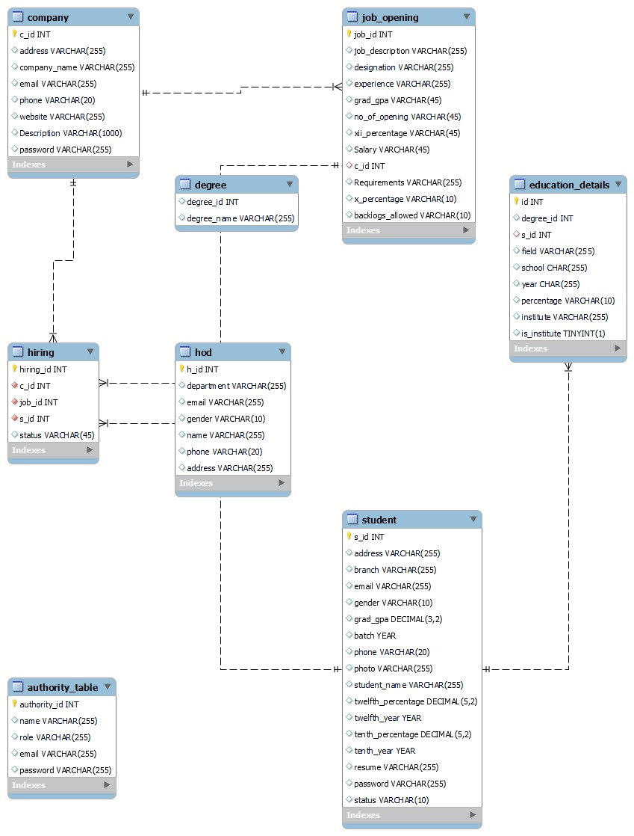
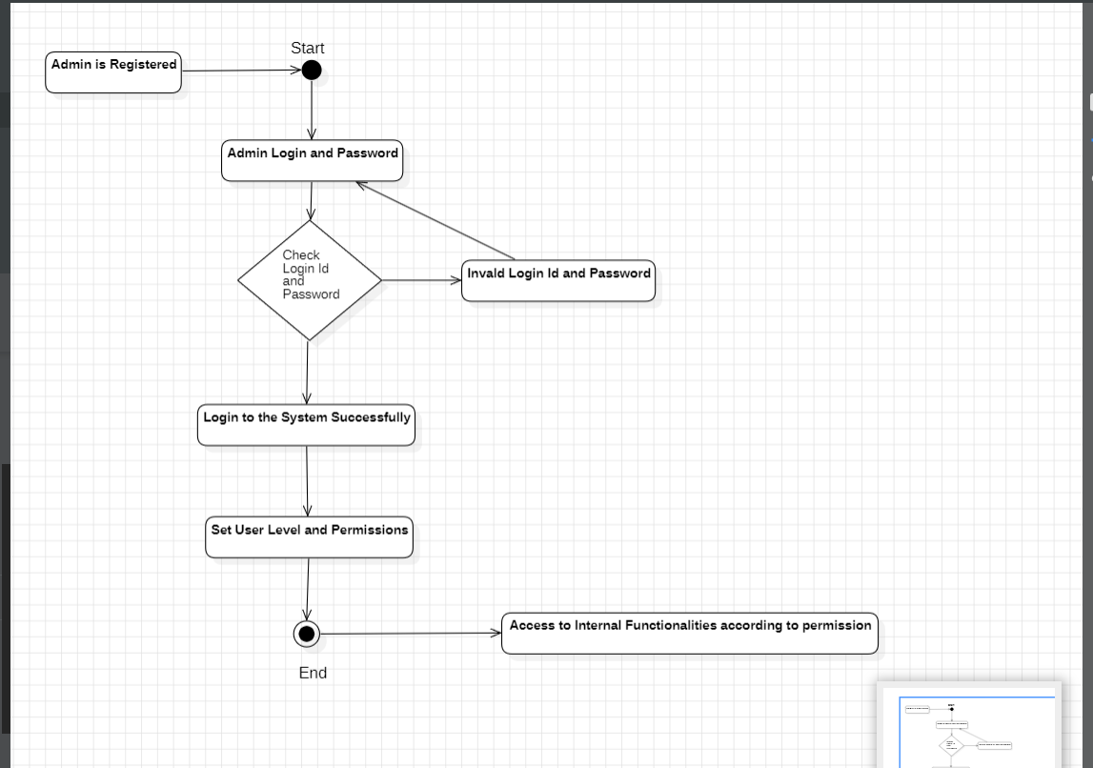

SDG MAPPING WITH JUSTIFICATION
SDG 4: Quality Education
Platform Role:
The placement system enhances the quality of education by supporting students with essential career-oriented tools. It offers updated interview questions, skill-based preparation material, and insights from previous candidates' experiences. These resources encourage lifelong learning, career readiness, and continuous skill development—empowering students to transition confidently into the workforce.

SDG 8: Decent Work and Economic Growth
Platform Role:
The system reduces youth unemployment by providing a structured, accessible platform for connecting students with a wide array of job opportunities. It ensures efficient and fair job-matching processes, promoting a smoother transition from academic life to employment. This contributes to economic growth by fostering a skilled, job-ready workforce and encouraging equitable access to decent work.

SDG 10: Reduced Inequalities
Platform Role:
The platform promotes equal access to placement resources, training tools, and employment opportunities regardless of a student’s background, caste, or socio-economic status. It ensures that every learner is treated fairly and provided with the same level of support, thus helping bridge inequality gaps and creating an inclusive and equitable placement environment.

CHAPTER 1
INTRODUCTION

1.1 Introduction
1.1 Overview
With the current digital age, technology has become an essential factor in making conventional systems more efficient and transparent. One of the areas in schools that needs to be modernized is the campus placement process. Conventionally, the placement process in colleges has been largely dependent on manual record-keeping, such as the use of Excel sheets and hard copies. This not only leads to inefficiencies, mistakes, and redundancy of data but also burdens placement coordinators with more work and restricts access for recruiters and students. To overcome these issues, this project suggests the creation of an online Placement Module—a centralized automated system aimed at simplifying and streamlining the entire recruitment cycle in educational institutions.

The Placement Module is a web-based, full-stack application designed to suit the requirements of three key user groups: students, recruiters, and placement officers. It is a holistic platform where firms can advertise job openings, students can apply accordingly on the basis of eligibility, and placement officers can regulate schedules, monitor progress, and produce reports. The system facilitates smooth communication between all concerned and guarantees equal and transparent recruitment.

1.2 Need for the System
Campus placements play a pivotal role in shaping the careers of students and building an institution’s reputation. However, manual handling of placement records poses numerous challenges:
- Data duplication and redundancy are common due to the use of scattered Excel sheets.
- Eligibility checking requires manual effort for each student against each company’s criteria.
- Scheduling interviews and updating results is time-consuming and often miscommunicated.
- Students lack access to real-time updates on job opportunities and application statuses.
- Placement officers must manually create reports and dashboards for institutional analysis.
These issues collectively hinder the effectiveness and scalability of campus placements, especially in institutions with large student populations. Thus, there is an urgent need for a centralized, digitized solution that minimizes manual effort and maximizes accuracy, speed, and accessibility.

1.3 Objectives of the Project
The main objective of the Placement Module project is to automate and enhance the existing campus placement procedures through a web-based platform. Specific goals include:
- Automating the placement process from job announcements to final selections.
- Providing real-time access to job openings, eligibility criteria, and application status for students.
- Simplifying the recruiter’s experience by enabling easy posting of job roles, filtering candidates, and scheduling interviews.
- Empowering placement coordinators to manage and monitor the entire process efficiently.
- Maintaining a central database for storing and retrieving student records, job postings, and selection outcomes.
- Minimizing administrative workload and eliminating data redundancy and human errors.
- Enhancing transparency and communication among stakeholders involved in the placement process

1.4 Scope of the Project
The project is primarily focused on the internal placement management system within an educational institution. The scope includes:
- Student Module: Registration, profile management, resume upload, job search, application tracking.
- Recruiter Module: Company registration, job posting, shortlisting eligible students, interview scheduling.
- Admin/Coordinator Module: Data verification, eligibility matching, event scheduling, analytics and report generation.
- Notifications: Real-time alerts via email or dashboard for job openings, interviews, and results.
- Data Management: Secure and structured storage of student academic records, resumes, and placement outcomes.
The system is designed using a full-stack architecture that combines a responsive frontend, efficient backend, and a secure relational database. It is scalable to accommodate the needs of institutions of various sizes and can be extended with additional features such as resume analysis, AI-based candidate matching, and integration with external job portals.

1.5 Methodology
The development of the Placement Module followed a structured approach, including the following phases:
- Requirement Analysis: Understanding the needs of students, recruiters, and placement coordinators through interviews and feedback.
- System Design: Creating wireframes, database schema, and system architecture for effective module integration.
- Implementation: Using HTML, CSS, JavaScript, Node.js, Express.js, and SQL for frontend and backend development.
- Testing: Performing unit testing, user acceptance testing, and security testing to ensure a robust and bug-free experience.
- Deployment: Hosting the system on a local or cloud-based server for accessibility and real-time use.
Each module was developed and tested iteratively, with continuous feedback incorporated to enhance functionality and user experience.

1.6 Benefits of the Placement Module
The implementation of this project yields numerous benefits, including:
- Reduced Administrative Burden: Automation of eligibility checks, scheduling, and data handling.
- Real-Time Access: Students and recruiters receive timely updates and notifications.
- Improved Transparency: All placement activities are recorded and accessible, reducing confusion and bias.
- Better Student Preparation: Integration of past interview questions, recruiter feedback, and skill-based resources.
- Institutional Insights: Dashboards and analytics help the institution track performance and make informed decisions.
- Fair and Equal Opportunities: All students have equal access to information and job roles, supporting inclusive growth.

1.2 Project Description
The Placement Module is an online application that is intended to make and automate the campus placement process easy. It was created with a mix of new web technologies to build an effective, user-friendly platform that helps students, placement coordinators, and recruiters.

For the frontend, the application utilizes HTML, CSS, JavaScript, Bootstrap, and Tailwind CSS. These technologies guarantee that the interface is responsive, clean, and user-friendly on both computers and mobile devices. The frontend enables users to navigate the platform easily, see job openings, apply for a job, and monitor their application status.

Backend is developed using Node.js and Express.js, which assist in handling server-side activities and user requests. For database, all significant information like student profiles, jobs, applications, and interview schedules is stored in a SQL database. The employment of REST APIs allows for secure and seamless communication between backend and frontend, facilitating data exchange between users and the system in real-time.

The platform supports three main types of users:
- Students can register, create their profiles, upload resumes, view job opportunities, apply for jobs, and receive real-time updates on their application status and interview schedules.
- Placement Coordinators can log in to post new job openings, set eligibility criteria, manage student applications, and schedule interviews. They can also generate reports and track the placement progress of students.
- Recruiters/Companies can register on the platform, post vacancies, filter and view student applications, shortlist candidates, and update results directly through the system.

The Placement Module features secure authentication functionalities to allow only authenticated users to log in to their respective dashboards. This ensures data security and user anonymity. Recruiters and students are provided with real-time updates by way of notifications on the platform for key events like new job vacancies or reschedule interviews.

A student database centralized enables coordinators to quickly search and filter candidates according to numerous criteria such as department, CGPA, skills, or resume keywords. Automatic tracking retains every application in a record, which makes it simpler to oversee the recruitment process from beginning to end.

By reducing manual work, the Placement Module minimizes errors and workload, and maximizes overall efficiency. It does away with the use of Excel sheets and manual verification of eligibility, making the whole process smooth and transparent. It also enhances communication and coordination among all users, as all those involved in the placement process have access to a common and updated system.

In summary, the Placement Module digitizes the traditional placement system. It assists schools in managing placements professionally, scalably, and accurately, and in making sure that companies and students have an enhanced experience. This project shows how technology can enhance key academic operations and aid students in gaining career success.

CHAPTER 2
LITERARY REVIEW
The digitization of placement procedures has been extensively researched within schools to enhance efficiency and ease of access. Conventional management of placements consists of manual keeping of records and communication, which is susceptible to errors, latency, and inefficiencies. Web-based placement systems have been seen to greatly boost coordination among recruiters, students, and placement officials through the automation of job listings, applications, and interview bookings, according to research.

Studies of web recruitment platforms focus on the strengths of centralized databases, instant notification, and safe authentication in promoting transparency and lightening administrative burdens. Numerous studies focus on web technologies such as HTML, CSS, JavaScript, and server frameworks such as Node.js and SQL in designing scalable and intuitive applications. REST APIs add more integration strength with third-party platforms with assured seamless data transfer.

Current literature further emphasizes the need for user experience in recruitment sites. User interfaces like intuitive dashboards, responsive design, and automated tracking enhance usability and user engagement. Security issues like data privacy and access control are similarly key factors to consider in placement systems.

The Placement Module enhances these observations by integrating high-end web technologies to automate recruitment processes, facilitate communication, and maximize the placement process. Through the elimination of the shortcomings of manual systems, it offers an effective and transparent solution for campus placements.

CHAPTER 3
PROPOSED SYSTEM
The Placement Management System proposed here will serve to integrate and manage the various tasks related to placement process of a particular organization starting from the placement officer, HOD, faculty coordinators to students. It enables students to feed their information and is taken and sorted academically through different user menus with operational privileges for the principles, HODs placement officers, coordinators and students both. Using MongoDB for database storage, the system will screen students based on the company criteria for recruitment and will send an email notification, which will inform interested candidates about the openings for the drives, where they can upload their interest.

To further enhance the system’s functionality, the following three implementations will be added:
Probability of Selection of Student in a Particular Company: A Concept as to Its Implementation
The Placement Prediction Feature is an innovative feature built into the Placement Module using historical recruitment information, student performance indicators, and company-specific requirements to predict the possibility of a student being given an offer by a given company. By looking into past placement patterns and correlating individual student profiles with profiles of successful candidates in the past, this feature brings data-driven decision-making into campus recruitment.

Historically, students have used guesswork or friends' recommendations to identify which firms they should be applying to. This tends to produce wasteful results—students will apply to jobs for which they are too underqualified, or, conversely, will not apply for positions for which they are appropriately qualified because they lack confidence or awareness. In the same vein, recruiters also spend a significant amount of time sorting through massive amounts of applications to shortlist qualified candidates by hand. The Placement Prediction system solves both problems by giving a probability score for each student with respect to each company.
The core of this system is a prediction algorithm trained on historical placement records. This data includes information such as:
- CGPA and academic performance across semesters
- Branch of study and course difficulty
- Participation in relevant certifications or online training programs
- Technical and soft skills listed in student profiles
- Internship experience and project work
- Participation in co-curricular and leadership activities
- Job roles offered in past placement seasons and their required skill sets

Comparing the profile of a student with those of successful ones from past years, the algorithm ascertains a probability score or matching percentage of a job opportunity. This score is the statistical measure of the potential for that student to be hired by a specific company based on previous trends.

This feature is extremely helpful for students as it provides them with individualized placement insights. Rather than applying sporadically to many companies, students can target their efforts where they have best chances. They can also find gaps in their profiles—like gaining a certification, an internship, or a specific skill—and proactively improve those areas prior to the next placement cycle. This promotes career planning strategically and reduces missed opportunities because of lack of information.

For placement officers, the software supports specific student training and improved company-to-candidate matching. If there is a low match rate among a set of students for a particular top recruiter, the placement team can schedule focused workshops, mock interviews, or skill-enhancement sessions to bridge the gap. It also facilitates proactive advising and support to students who might be struggling with baseline expectations.
From the recruiter's point of view, this functionality can serve as a pre-screening mechanism. When a batch of applicants is received, recruiters can see prediction scores provided by the system and shortlist candidates who statistically match their previous hiring behavior. This leads to more effective and relevant interviews, better conversion rates, and enhanced satisfaction for employers and job seekers alike.
Technically, this can be done with machine learning models like logistic regression, decision trees, or neural networks trained on labeled placement data. It can also include real-time updates to improve prediction accuracy as new data is available during continuous placement drives.
In addition, the feature supports ethical concerns by preserving transparency and allowing feedback loops. Students are able to comprehend the grounds of their prediction scores as well as receiving suggestions for how to improve compared to being objectively judged.
In short, the Placement Prediction Feature adds intelligence and personalization to the placement process. It serves all the stakeholders—students, placement coordinators, and recruiters—by adding transparency, efficiency, and strategic thinking, to career choice making. It eventually bridges the gap between opportunity and potential, enhancing the campus placement process to be stronger, data-driven, and future-proof.

Use of the Resource Sharing Feature for Students during Recruitment
This function is aimed at increasing the overall success of students in the hiring process through promoting collaboration and sharing of precious assets. Through creation of a platform where students can share their experiences, advice, and documents, the function hopes to establish a collaborative and sharing environment. The intent is to enable students to excel in interviews, tests, and other hiring-related exercises, and finally land jobs in an intense job market.
One of the important aspects of the feature is students' ability to share documents that pertain to their interview experience. Such documents may include resumes, cover letters, and other application materials students have employed when searching for employment. Through the uploading of such documents on the platform, students can provide others with an idea of how they personally approached applying for jobs and offer instances of what succeeded best for them. This exchange of documents will assist students in knowing what employers want from applications and how to organize their own materials in a way that they can gain recognition.
Aside from sharing application documents, the feature will allow students to share their experience at interviews. This may encompass a description of the kind of questions asked in interviews, the way the interview was organized, and any hints or tips which assisted them to be successful. Interviews may be intimidating, particularly for new students who have just begun looking for work. Through hearing about others' experiences, students can better know what to do, how to prepare, and how to respond to a variety of interview questions. This sharing of knowledge in the platform will generate a community and sense of support amongst students to work together and support one another's success.
Yet another useful feature of the platform will be the exchange of company-specific advice and tips. Each company has its own culture, expectations, and values, and getting to know these things can make a big difference while applying for jobs. Students can exchange tips about particular companies, such as any insider tips or tricks that assisted them during the hiring process. For instance, they may be able to disclose information regarding a company's interview process, the sort of tests or assignments conducted, and the traits the company seeks in potential applicants. This kind of information can assist other students in adapting their applications and preparing better for interviews or tests with that company.
In order to better assist students, the site will also offer suggestions on how best to prepare for different recruitment-based exercises. These exercises may be in the form of case studies, aptitude tests, technical problems, or group discussions. By providing tips on how to tackle these exercises, the platform will assist students in developing the skills and confidence required to excel. This may involve tips on time management, problem-solving techniques, and effective presentation of ideas. In addition, the platform could feature sample exercises or practice questions that students can use to test their knowledge and improve their performance.

One of the most powerful features of this platform is the ability to foster collaboration and peer support. By participating in discussions, students can ask questions, share advice, and receive feedback from others who have gone through similar experiences. This produces a co-operative learning atmosphere where students are not only able to learn from other people but also share their own experience and expertise. For instance, students who have been able to overcome a tough interview or test can provide useful tips to others who are going to take a similar challenge. In return, students who are yet to reach the peak of their career search can request assistance, air their fears, and build confidence as they ready themselves for future recruitment activities.

The site may also have a discussion forum or a database where students can quickly access and search for particular topics, documents, and tips. This would enable students to access relevant information quickly, whether they are searching for general tips or company-specific tips. By structuring the content in an easily accessible manner, the site makes sure that students are able to utilize the resources provided to them to the fullest.

Finally, this feature seeks to provide an area where the students can get into touch, learn from and support each other during the recruitment process. Through the sharing of experiences, documents, and advice, the site will enable students to develop the understanding and competency that they require to excel at interviews, tests, and other recruitment exercises. Supported by their fellow students and provided with beneficial resources, students will be more likely to feel confident when tackling the job search process and improve their odds of finding their ideal jobs.

Placement of Recruitment Stage Tracking in Placement Module
The Recruitment Stage Tracking Module is one of the main features that add value to the overall operation of the Placement Management System, and it's a way of handling and tracking the recruitment process in a systematic and transparent manner. The module is intended to benefit both administrators and students by enhancing the efficiency and organization of the recruitment process. Through its provision of live updates and comprehensive insight into each candidate's process through different recruitment stages, the module assists in minimizing uncertainty among students as well as simplifying the workflow for placement officers and recruiters.

Providing one of the main purposes of the Recruitment Stage Tracking Module is to present a clear step-by-step understanding of the recruitment process. The recruitment stages will be deconstructed by the module into major milestones like application submission, test completion, interview cycles, and final selection decision. Every step will be graphically represented on the platform, making it easier for students and placement officers to monitor the progress of every candidate in real-time. This transparency is particularly beneficial to students, as it makes them aware of where they are in the recruitment process and what remains to be done before the final decision is reached.

For placement officers, the Recruitment Stage Tracking Module is a precious asset to track several recruitment processes at the same time. In most instances, placement officers deal with a lot of students who are applying for different positions within several companies at once, making it easy for the work to pile up in no time. Without an orderly system to follow each candidate through, it can be hard to keep track of all the running recruitment processes. This module relieves this issue by presenting a single point where placement officers can observe the status of each student, saving them from repeated follow-ups or manual monitoring. With a few clicks, they can observe the status of a candidate at any stage of the recruitment process, ranging from application submission to final shortlisting.

The other significant benefit of this module is that it can eliminate uncertainty for students. One of the most stressful parts of the hiring process is a lack of communication and feedback on a candidate's status. Students frequently feel confused about where they are in the process, and this can cause anxiety and unwarranted follow-up emails to placement officers or recruiters. Once the recruitment tracking system is implemented, students are provided with instant information regarding the status of their applications, test scores, and interview phases. This can decrease nervousness to a great extent and provide students with a clear idea of what they have to do next. Additionally, by lessening the requirement of frequent status questions, students will be able to concentrate on working towards the subsequent phase of the process, instead of asking themselves about their application's status.

The recruitment stages will be organized systematically within the module, with each step being clearly defined and easy to track. For example, the stages could include:
- Application Submission: This stage marks the point when students submit their application for a particular job. The module will track when applications are received and ensure that no applications are missed or lost in the process.
- Test Completion: Many companies require candidates to take various assessments, such as aptitude tests or technical exams. The module will track when these tests are completed, and the results will be recorded in real-time. Placement officers will have easy access to this data, enabling them to quickly determine if a candidate has progressed to the next stage.
- Interview Rounds: Depending on the company, candidates may go through several rounds of interviews, including initial screenings, technical interviews, and final HR interviews. The module will track the completion of each interview round, providing placement officers with a comprehensive view of the candidate’s progress.
- Final Selection: This stage marks the final decision made by the company regarding the candidate’s selection. The module will provide placement officers with clear information about whether a candidate has been selected or rejected, and any feedback provided by the company.
By offering regular updates and easy access to information at every stage, the Recruitment Stage Tracking Module helps keep both students and placement officers informed and organized. This feature also benefits recruiters and employers, as it allows them to manage candidate pipelines more efficiently and make informed decisions faster.
Moreover, the module will be integrated with the overall Placement Management System, allowing for a seamless connection between students, placement officers, and employers. This integration ensures that all relevant data is automatically synchronized and available across the platform. For instance, once a student progresses through a stage, such as completing a test or interview, the information is updated in real-time, ensuring that all parties involved have the most up-to-date information.
In conclusion, the Recruitment Stage Tracking Module significantly enhances the Placement Management System by improving the efficiency, transparency, and organization of the recruitment process. By providing real-time updates and tracking, it not only helps reduce uncertainty and anxiety for students but also streamlines the workflow for placement officers and employers. This comprehensive tracking system ensures that all users—students, institutions, and employers—have access to the tools and information they need to succeed in the recruitment process. Ultimately, this module is an essential enhancement that will make the Placement Management System more effective and valuable for everyone involved in the recruitment and placement process.

CHAPTER 4
REQUIREMENT ANALYSIS AND SYSTEM SPECIFICATION
4.1 Feasibility Study
A feasibility study is an important component in determining the likelihood of success of a project through assessing its technical, financial, and operational feasibility. The Placement Module is not exempted from this, as it entails a mix of technological, financial, and operational factors that will guide its efficacy and sustainability in facilitating the recruitment process for students, placement officers, and employers. This part gives a detailed analysis of the Placement Module's feasibility from three important points of view: technical, economic, and operational.

4.1.1 Technical Feasibility
Technical feasibility of the Placement Module is concerned with the capability to develop, deploy, and sustain the system with existing web technologies. The project is built on commonly used and stable web technologies, including HTML, CSS, JavaScript, Bootstrap, and Tailwind CSS for the frontend and Node.js, Express.js, SQL, and REST APIs for the backend. These technologies are not only industry standards but also provide great scalability and maintainability, making sure that the Placement Module can scale with the users' needs.

Frontend development frameworks such as HTML, CSS, and JavaScript form the groundwork for designing a user-friendly and responsive user interface, which is crucial to the user experience. Bootstrap and Tailwind CSS go a step further in strengthening the frontend by enabling developers to develop mobile-friendly, responsive web pages that adjust according to devices. This ensures the system remains usable by users on different platforms, whether they use a desktop, tablet, or smartphone.

In the backend, Node.js and Express.js offer a strong and effective infrastructure for server-side logic handling, allowing the system to process data requests, interact with databases, and serve content in a smooth manner. SQL, as the database management system, allows for organized data storage that is consistent and easily queried for candidate status, recruitment stages, and user profiles. The use of REST APIs facilitates seamless communication between frontend and backend for real-time updating and synchronization of data.

All these technologies have strong support from the developer community, which guarantees that there exists a huge pool of resources, tutorials, and best practices that can be leveraged for debugging and further development. The system will further be extendible with ease, such that while the placement process changes or extra features are added, the system can be adapted to accommodate new requirements without heavy overhauling. Generally speaking, the technical viability of the Placement Module is high since it takes advantage of contemporary web application development technologies which are scalable, maintainable, and future-compatible integration needs.

4.1.2 Economic Feasibility
Economic feasibility evaluates the financial viability of the Placement Module in terms of development and operational expenses. One of the key strengths of this system is its use of open-source technologies. Open-source software like Node.js, Express.js, and SQL are free to use and do not need costly licenses, thereby keeping the initial expenses related to purchasing software very low. This savings on licensing enables the more cost-effective development process, particularly for academic institutions or entities that might be developing within tighter fiscal boundaries.

In addition, the deployment of the Placement Module can be done on institutional servers or cloud servers, lessening infrastructure expenses. Cloud hosting providers such as AWS, Google Cloud, or Microsoft Azure have scalable and adjustable pricing plans, so the system can expand along with demand without paying large amounts of initial hardware costs. Institutions or organizations can only pay for the resources that they consume, lessening the total expense and offering a cost-effective solution to server infrastructure.

For long-term savings, the automation functions of the Placement Module, for example, auto-updates of recruitment progress and tracking of candidates, can reduce the workload of placement officers dramatically. By minimizing manual tasks like data entry, follow-ups, and status enquiries, the system can save quite a lot of time, where staff can divert their attention towards more strategic tasks. This easing of administrative workload means long-term savings in human resources costs as well as improving operational efficiency.

In addition, the Placement Module would also offer useful insights into placement patterns, which can be used to guide future recruitment and resource planning. Through real-time information on candidate progress and employer demand, the system enables institutions to make informed decisions, maximizing their investment in recruitment activities.

4.1.3 Operational Feasibility
Operational viability assesses the extent to which the Placement Module will be practicable and functional in actual application, considering ease of uptake by the different stakeholders involved, such as the placement coordinators, students, and recruiters. The system has been developed with user experience in mind, such that the interface is easy to use, intuitive, and usable by users with different levels of technical skills.

For placement officers, the system eliminates much of the mundane administrative work involved in tracking candidates' movement between the recruitment phases, interviewing scheduling, and follow-up with recruiters. This minimizes chances of errors while enabling placement officers to manage multiple recruitment drives concurrently without getting bogged down. Automated reminders, instant updates, and integrated dashboards ensure it is simple for placement officers to keep abreast of recruitment activities without needing frequent follow-ups and status reports.

Students are advantaged by the system's simplicity and user-friendliness, featuring an interface where they can monitor their application progress, get real-time updates about interviews, and access relevant preparation resources. Each step in the recruitment process's clear visibility erases uncertainty, enabling students to remain engaged and focused on readying themselves for the next phase.

Recruiters also find the system operationally efficient, as it offers a streamlined process for candidate applications, interviewing, and feedback. Through the incorporation of real-time data, recruiters can make quicker decisions, enhancing the overall speed and efficiency of the hiring process.

In summary, the operational viability of the Placement Module is robust since it provides an easy-to-use interface, effective automation, and smooth integration with the workflow of all stakeholders—placement officers, students, and recruiters. The design of the system focuses on ease of use and usability to ensure that it can be easily adopted without much training or process disruption.

4.2 Software Requirement Specification

The Software Requirement Specification (SRS) provides the system requirements needed for the proper implementation of the Placement Module. This component provides the data, functional, performance, maintainability, and security requirements that are all essential to making sure that the system will serve the needs of the students, placement coordinators, and recruiters. Through these specifications, the Placement Module will be in a position to operate effectively, securely, and efficiently in such a way that there will be a smooth experience for the use of all stakeholders involved.

4.2.1 Data Requirement
The Placement Module will need the following data to be effective:

Student Information:
- Personal Details: Name, roll number, qualification, and contact details are required for student identification and proper matching with job vacancies.
- Resume: Student resumes will be stored in a standard format by the system so that recruiters and placement officers can review and shortlist applications with ease based on qualifications, experience, and skills.
- Application Data: The system will monitor which jobs have been applied for, the status of each application, and what extra documents or forms are demanded by the recruitment process.

Company Information:

- Company Details: Industry, name, and contact information.
- Job Positions: Details on the positions being offered, job descriptions, required skills, and job location.
- Eligibility Criteria: Requirements on the qualifications, experience, and skills demanded for each position.
- Recruitment Process: Details on the stages of recruitment, any tests, interviews, or assessment rounds that are conducted, and any particular deadlines for each round.

Application Data:
- The application process should be supported by the system, including student information, job preferences, and monitoring of the progress of the application. This includes automatic monitoring of application stages (submission, test, interview, and selection).

Interview Schedules and Outcomes
- The system will retain information regarding interview timetables, including date, time, venue (or virtual meeting link), and interviewer information. Interview results (pass/fail, feedback, etc.) will also be monitored and reported to students so that they can prepare for the next phase.

4.2.2 Functional Requirement
The Placement Module should have the following fundamental functionalities:

User Authentication:
- Student, Coordinator, and Recruiter Authentication: Secure login credentials and role-based authentication must be used by all users (students, placement coordinators, and recruiters) to guarantee access to the correct features. Placement coordinators will have administration access, recruiters will have access to job posting and management of applicants, and students will have access to tracking their applications and job listings.

Job Posting and Application Submission:

- Posting of Jobs: The recruiters must be able to post job vacancies by providing detailed information regarding the post, eligibility conditions, and selection process.

- Job Applications: The students can apply for jobs listed by uploading their resumes and completing any forms that may be required. The system will check the applications against the eligibility conditions.

Resume Management and Candidate Filtering
- The system must enable placement coordinators and recruiters to filter and manage student resumes based on qualification, skills, experience, or other factors to facilitate effective candidate selection.

Interview Scheduling and Alert System:
- The system will schedule interviews automatically based on recruiter preference and student availability. It will also notify students and recruiters of impending interview dates, schedule changes, or interview results.

Live Status Updates:
- The students ought to receive up-to-the-minute feedback about the status of their application, like if they have been shortlisted for an interview, receiving feedback for the interviews, or getting selected/rejected.

4.2.3 Performance Requirement
The following should be met in terms of the system's performance:

Multi-user Handling
- The system should have the capacity to support numerous concurrent users without slowing down. This encompasses students who are seeking employment, placement coordinators who are overseeing applications, and recruiters who are screening resumes or conducting interviews. The system ought to accommodate hundreds or thousands of users concurrently without any perceivable lag in responsiveness.

Rapid Data Retrieval and Updates
- The system must offer fast response times for fetching data, updating records, and showing real-time status updates. The response time for loading pages or fetching application status should be no more than a few seconds to ensure a seamless user experience.

Effective Database Queries
- Database queries need to be optimized in terms of speed, particularly for intricate search and filtering operations. For example, when students look for job advertisements or recruiters filter through resumes, queries need to run quickly with results coming almost in real time.

4.2.4 Maintainability Requirement
The system needs to be maintained and updated with ease:

Modular Code Organization:
- The code must be structured into clean, modular blocks to make debugging, troubleshooting, and feature updates easy. Each module, for example, the job listing system or interview scheduling feature, must be independent of the others so that updates are easy without impacting the entire system.

Periodic Database Backups:
- The database should be backed up regularly to avoid data loss in the event of server failure or otherwise. Backup plans should involve full backups at periodic intervals and incremental backups of changes made during the course of a day to avoid maximum data loss.

Scalable Architecture:
- As the quantity of users and job postings increases, the system needs to scale without interruption. Whether running locally on servers or cloud infrastructure, the architecture of the system must support adding storage, memory, and processing capability without major disruption or re-designing.

4.2.5 Security Requirement
Security is an important issue for the Placement Module since it will be dealing with sensitive student data, job vacancies, and employer data. The system should also live up to security best practices:

Secure Login with Encrypted Passwords:
- User credentials (username and password) should be stored securely using encryption mechanisms such as bcrypt or hashing techniques to avoid user account unauthorized access.

Role-Based Access Control:
- The system must apply role-based access control (RBAC) to limit access to features according to the user's role. Students will be allowed to view job postings and application tracking, while recruiters and coordinators will be granted extra privileges like resume filtering, interview scheduling, and job posting.

Protection against SQL Injection and XSS Attacks:
- Input validation methods must be used to avoid SQL injection, cross-site scripting (XSS), and other malicious attacks. For instance, user input in job applications, resumes, and forms should be sanitized to remove the possibility of code injection.

Data Encryption for Sensitive Information

- Sensitive information like student contact information, resumes, and application status must be encrypted both in transit (with HTTPS) and stored at rest in the database. This guarantees user data security and privacy.

4.3 SDLC Model Used
Agile Model was selected in this project because it has an iterative development model through which ongoing improvement was achieved according to stakeholder input. Important advantages are:

Incremental Development – It is developed in phases, where it is possible to test early on and make necessary improvements.
User Collaboration – The system was fine-tuned regularly with input from placement coordinators and students.
Flexibility – It facilitated modifications according to changing requirements without breaking the development cycle.
This model assured the Placement Module was built effectively, with regular updating and upgrading.
4.4 System Design
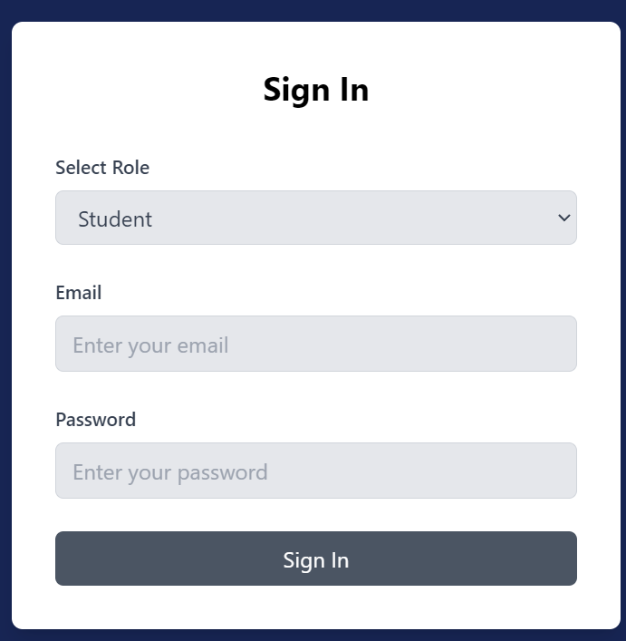
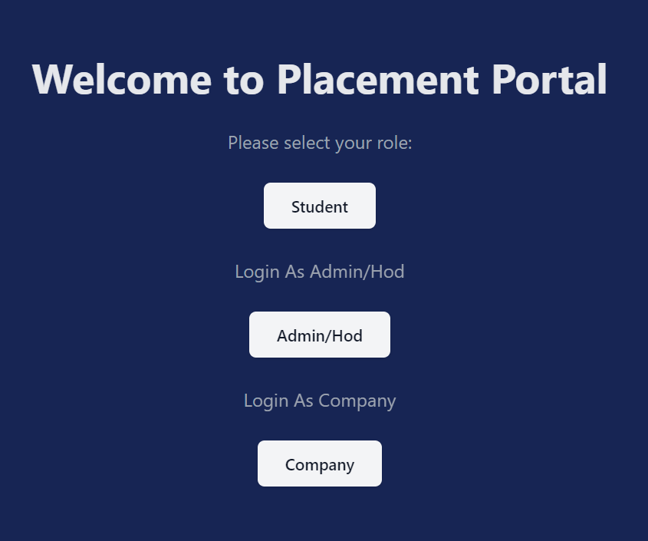
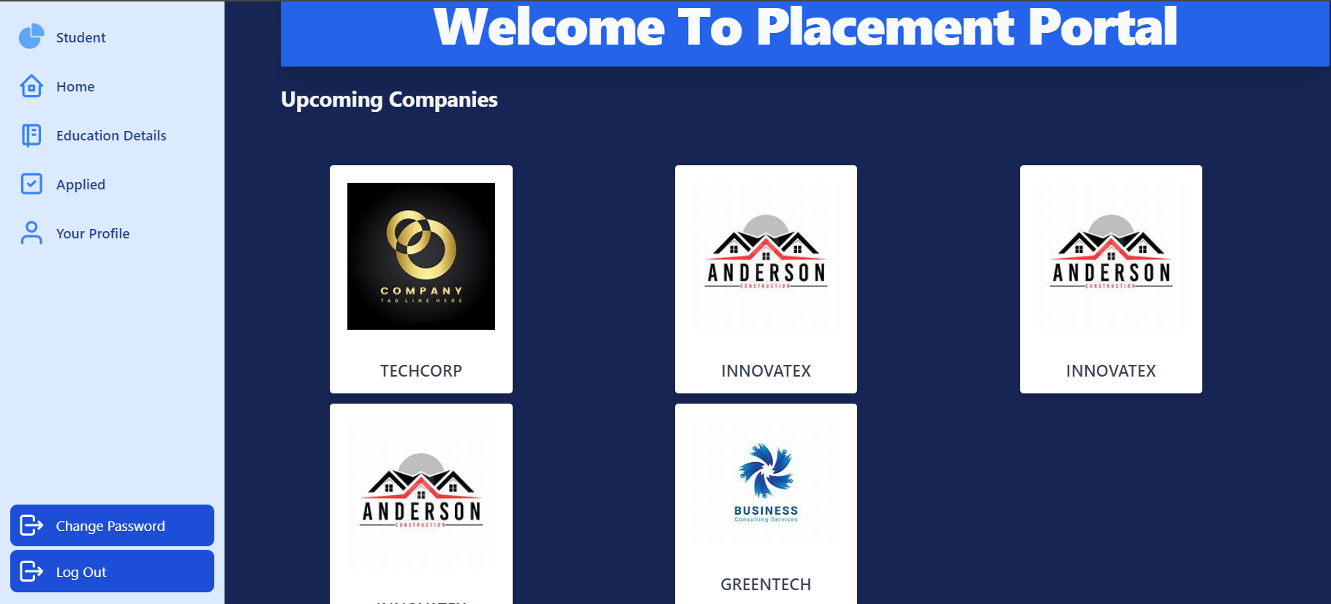
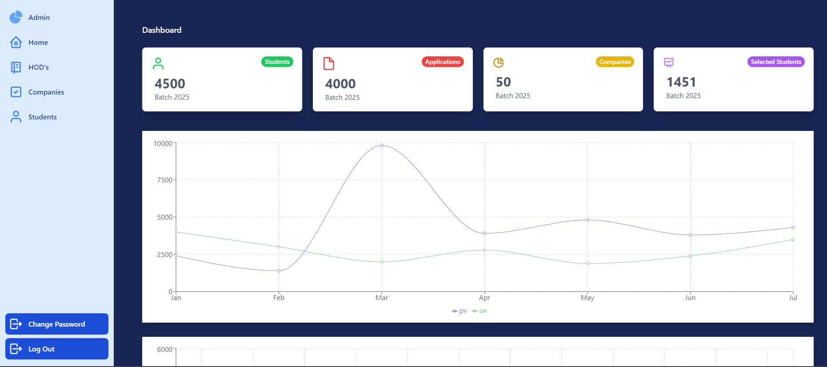
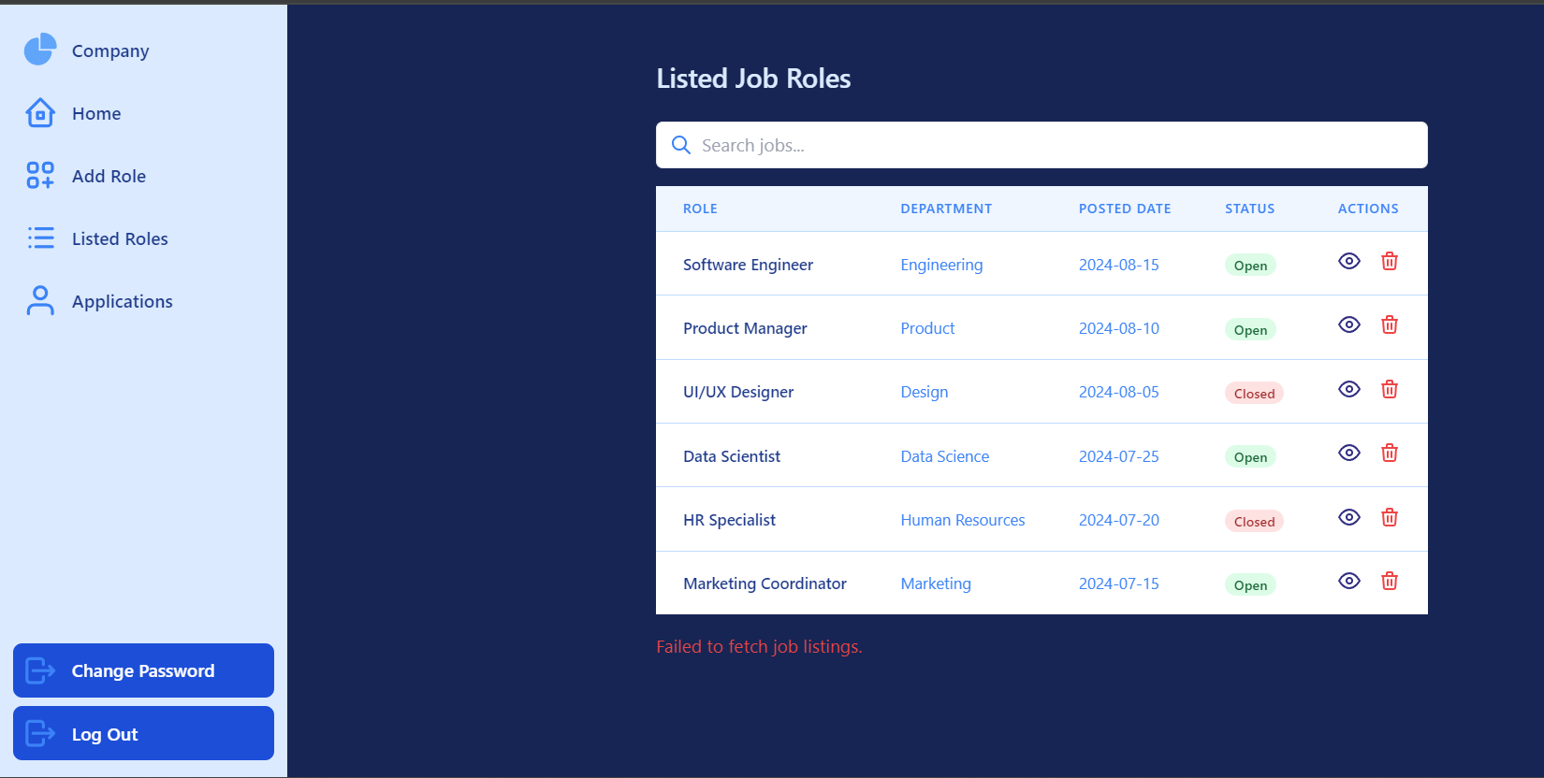

4.4.1 Data Flow Diagrams
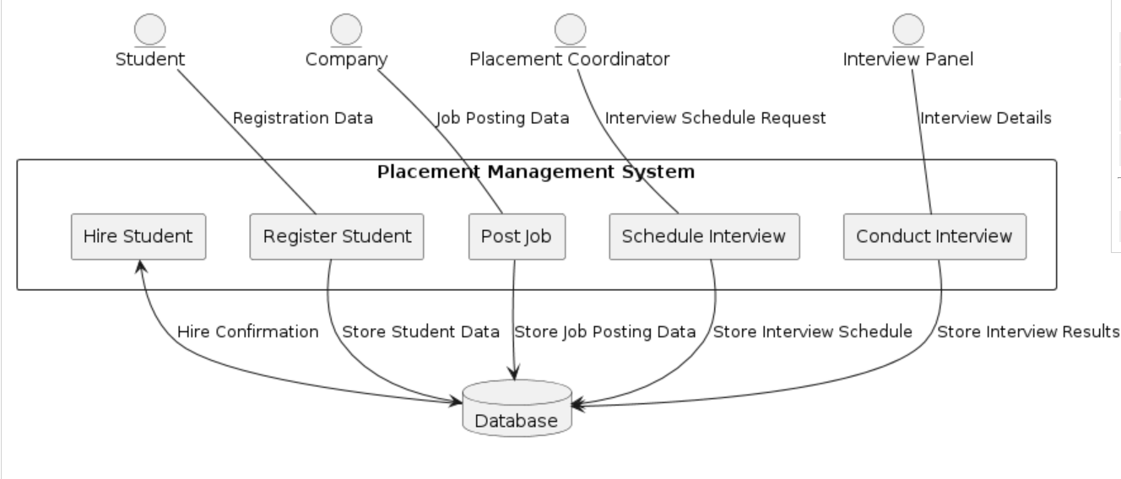

4.4.2 Use Case Diagrams
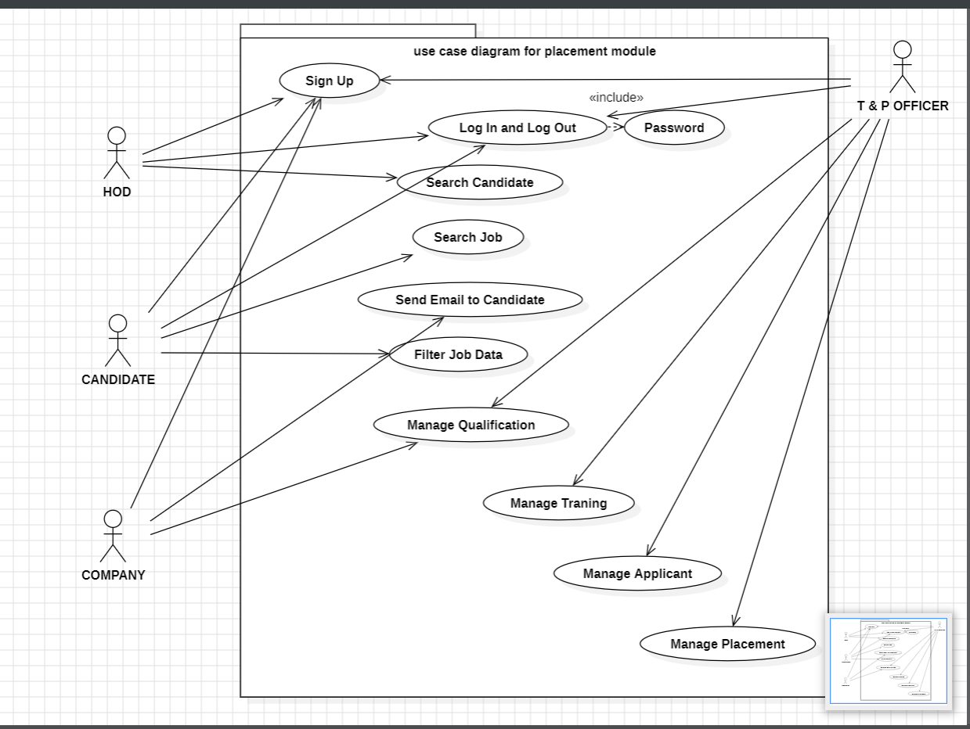

CHAPTER 5
IMPLEMENTATION

5.1 Introduction
The implementation process entails translating the designed system into a functional Placement Module. It entails creating the development environment, coding, linking system components, and testing the functionality. The Placement Module was coded based on a structured process to allow seamless deployment and effective performance.

5.2 Technology Stack Used
- Frontend: HTML, CSS, JavaScript, Bootstrap, Tailwind CSS
- Backend: Node.js, Express.js
- Database: SQL (MySQL/PostgreSQL)
- APIs: REST APIs for data communication
- Authentication: JWT-based secure login system

5.3 Implementation Steps
5.3.1 Setting Up the Environment
- Installed required software: Node.js, Express.js, SQL database, and frontend libraries.
- Set up a version control system (GitHub) for code management.

5.3.2 Database Design & Setup
- Designed database tables for Users, Jobs, Applications, and Notifications.
- Defined relationships between entities to maintain data integrity.

5.3.3 Backend Development
- Implemented REST APIs for job posting, application, and interview schedule handling.
- Added authentication and authorization mechanisms.

5.3.4 Frontend Development
- Designed an intuitive user interface with HTML, CSS, JavaScript, and Bootstrap.
- Integrated API calls to fetch and display dynamic data.

5.3.5 Testing & Debugging
- Conducted unit testing and integration testing for each module.
- Fixed identified bugs and optimized performance for smooth execution.

5.4 Deployment
- Deployed the Placement Module on a cloud server or local institutional server.
- Maintained proper system monitoring and database backup for maintenance.

Successful implementation of the Placement Module effectively computerized the placement process, offering a robust and easy-to-use platform for students, recruiters, and coordinators.

CHAPTER 6
TESTING AND MAINTENANCE
1. Improved Efficiency
The Placement Module significantly enhances efficiency by automating many aspects of the recruitment process that were previously manual, reducing the time and effort required by placement coordinators and students alike.
- Automation of Job Advertisements: Job postings are automated within the system, allowing recruiters to easily input and publish job vacancies without needing to manually distribute advertisements. This speeds up the recruitment process, ensuring that job listings are available to students immediately and reducing the workload of coordinators.
- Streamlined Application Process: Students can submit applications quickly through the system, avoiding the need for physical documents or manual follow-ups. With the click of a button, students can apply to multiple positions at once, and the system ensures that all applications are stored in an organized manner. This streamlined process minimizes time wasted on administrative tasks and allows students to focus on preparing for interviews and other stages of recruitment.
- Automatic Interview Scheduling: The system automatically schedules interviews based on availability and preferences of both recruiters and students. With integration of calendar systems and real-time updates, scheduling becomes seamless, removing the risk of double-booking or missed appointments. Coordinators benefit from less manual intervention and are better able to manage multiple recruitment drives simultaneously, increasing overall operational efficiency.
- Real-Time Updates: Automated notifications alert students and recruiters about the latest updates in the recruitment process, such as shortlisting for interviews, changes in schedules, or the final status of an application. This reduces the need for repetitive follow-ups, minimizing human errors and speeding up the overall recruitment cycle.
- Reduction in Errors and Redundancy: Manual processes often lead to errors, such as misfiled applications or overlooked documents. The Placement Module minimizes human error through automated workflows, ensuring that all information is processed accurately. Additionally, eliminating redundancy helps reduce unnecessary work, such as manually entering the same data multiple times.
2. Improved User Experience
The Placement Module places a high emphasis on user experience, ensuring that all stakeholders—students, recruiters, and placement coordinators—can easily interact with the system and accomplish their tasks with minimal effort.
- Responsive Design: The system is built with responsive web design principles, using technologies like HTML, CSS, JavaScript, and Bootstrap to ensure that it works seamlessly across all devices, including desktops, tablets, and smartphones. This flexibility ensures that users can access the platform at their convenience, whether at home, in class, or during internships, making the system highly accessible and improving engagement.
- Intuitive Interface: The user interface (UI) is designed to be intuitive, making it easy for users to navigate through various sections like job listings, application status, interview schedules, and notifications. The system minimizes the learning curve, enabling even non-technical users, such as students, to quickly familiarize themselves with the platform and make the most of its features.
- Real-Time Messaging and Communication: The real-time messaging system allows students, recruiters, and placement officers to communicate instantly. Whether it’s to clarify details about job positions, discuss application progress, or provide feedback after an interview, this functionality fosters a transparent and interactive recruitment process. By integrating real-time communication, the system enhances engagement between students and recruiters, leading to faster decision-making.
- Personalized Dashboards: Each user (students, coordinators, and recruiters) has access to a personalized dashboard that displays relevant information based on their role. Students can easily track their applications and interview schedules, recruiters can manage job postings and view candidates’ profiles, and placement coordinators can oversee the overall recruitment process, all from a centralized interface. This personalization ensures that users can quickly find the information they need without unnecessary navigation.
- User-Friendly Notifications: The system provides notifications through various channels (email, system alerts, etc.) about important updates, such as interview invites, test results, or job postings that match a student’s qualifications. These notifications ensure that users never miss important events, enhancing the overall user experience and engagement.
3. Improved Data Management
Efficient data management is at the core of the Placement Module, providing accurate, real-time access to student and recruiter information, while ensuring that the system is scalable, reliable, and secure.
- Centralized Database: The use of a centralized SQL database ensures that all data—student profiles, resumes, job postings, and application statuses—are securely stored in one location. This centralization allows for easy data retrieval and ensures that users can access up-to-date information quickly. This also enables placement coordinators to monitor all ongoing recruitment activities in real-time.
- Structured Data Storage: Data related to students, recruiters, and job applications is structured in such a way that it can be easily queried and filtered. For instance, placement officers and recruiters can filter resumes based on keywords, qualifications, experience, or job preferences. This structured approach makes it easy to manage large volumes of data while ensuring fast access to relevant information.
- Seamless Data Transfer via REST APIs: The system’s REST API architecture allows for seamless data transfer between the frontend and backend, ensuring that data is updated in real-time. When a student submits an application or a recruiter updates an interview schedule, the system reflects these changes instantly, providing up-to-date status information to all users.
- Data Integrity and Validation: The system includes robust data validation processes to ensure the accuracy and consistency of the information. For example, when students submit applications, the system checks for missing or incorrect information before allowing submission. This reduces the risk of errors, ensures completeness, and improves the quality of the data stored.
- Backup and Recovery: The system includes periodic backups to prevent data loss in the event of a failure. These backups ensure that all information, including student profiles and recruitment statuses, is securely stored and can be recovered if necessary, providing additional reliability and reducing the risk of data corruption or loss.
4. Greater Transparency
Transparency in the recruitment process is essential for building trust and ensuring fair opportunities for all candidates. The Placement Module enhances transparency for both students and recruiters by providing clear and accessible information at each stage of the recruitment process.
- Real-Time Application Tracking: Students can easily track the progress of their applications, from submission to final selection. They can see if they’ve been shortlisted, if their interview is scheduled, or if they’ve been rejected. This visibility eliminates uncertainty and reduces the need for repeated inquiries to placement coordinators or recruiters.
- Recruiter Feedback: Recruiters can provide immediate feedback after interviews, and students can view this feedback directly in the system. This transparency allows students to understand their strengths and areas for improvement, fostering a learning experience even if they are not selected for a particular position.
- Status Updates for Recruiters: Recruiters are notified of candidate progress and interview schedules, helping them stay informed and make decisions efficiently. This transparency ensures that recruiters have all the information they need at their fingertips, improving communication and reducing delays in the hiring process.
- Secure Authentication Processes: The Placement Module uses secure login mechanisms to ensure that only authorized individuals can access sensitive information. With role-based access controls, students, recruiters, and placement coordinators can only access information relevant to their role, enhancing data privacy and security.
- Audit Trails and Logs: The system keeps detailed logs of all user activities, from job postings to interview scheduling, ensuring that all actions are traceable. These logs provide an additional layer of transparency, helping placement coordinators and administrators monitor and verify actions, which can be critical in case of disputes or issues.

The testing phase of the project was designed to ensure the overall quality, reliability, and effectiveness of the Flutter-based frontend. A well-structured testing strategy was pivotal to meeting the project’s goals, guaranteeing that the application functioned as intended and adhered to the specifications. To enhance the testing process and ensure swift issue identification and resolution, the team employed tools like Mantis BT for defect tracking and Selenium IDE for automated testing. These tools were selected for their efficiency and effectiveness in addressing potential issues, while also streamlining the testing process. The goal was to provide an uncomplicated user interface, as well as reliable and effective performance across various devices. Below, we elaborate on the core testing strategies that were implemented to ensure a seamless experience for end users and stakeholders.

1. Requirement-Based Testing
Requirement-based testing focused on verifying that the application met the pre-defined project requirements. These requirements covered various aspects of functionality, usability, and performance, all of which were essential to the success of the project. Before beginning the testing process, clear and concise requirements were outlined to ensure that all test cases were aligned with the project’s objectives. The testing team used these requirements to create specific test scenarios that would validate whether the system was functioning as expected and meeting the needs outlined by the stakeholders.
The requirement-based testing approach provided several benefits. It ensured that all aspects of the application were tested according to the predefined needs, eliminating the risk of overlooking key functional components. Additionally, this approach was instrumental in identifying any gaps between the initial design and the actual output. By tracing the success of each feature against the requirements, the team ensured that the system was aligned with user expectations, as well as any legal, regulatory, or business constraints.

2. Functional Testing
Functional testing was an essential part of the testing phase, focusing specifically on validating the core features and functionality of the Flutter-based frontend. This type of testing aimed to ensure that all features, such as input forms, navigation, and data visualization components, worked correctly and efficiently. Each individual function of the app was tested independently to ensure that it performed its intended role without any errors or glitches.
Functional testing also helped verify that the system’s logic was sound, confirming that input data produced the expected output and that the application responded to user actions in a predictable manner. The team simulated real-world interactions to ensure that all features were usable, intuitive, and delivered the expected results. This type of testing was particularly useful in identifying discrepancies between the expected functionality and actual behavior, allowing the team to resolve defects before deployment.

3. Integration Testing
Integration testing played a critical role in ensuring that the Flutter frontend communicated effectively with the backend services, APIs, and other system components. This type of testing was designed to validate that various parts of the system worked together as expected, without any conflicts or failures in the data flow. Integration testing aimed to identify any issues that could arise when different modules or services interacted with each other.
A key aspect of integration testing was the verification of API calls, ensuring that data was transmitted correctly between the frontend and backend. The team verified that all responses from the backend were correctly displayed on the frontend, confirming that the data displayed in the user interface was accurate and up-to-date. This phase was critical in detecting issues related to mismatched data, communication errors, and integration points that could potentially hinder the app’s performance.

4. Usability Testing
Usability testing focused on evaluating the user interface (UI) for ease of use, accessibility, and responsiveness. Given that the application was built using Flutter, which supports cross-platform development, ensuring the app's seamless performance on different devices was a priority. The usability testing team focused on making sure the app was easy to navigate, intuitive for end-users, and accessible to users with different abilities.
Usability testing involved assessing the design of the interface, the clarity of instructions and labels, and the overall user experience across various screen sizes and devices. The team tested the app on both Android and iOS devices to ensure that the UI elements adapted correctly, maintaining a consistent experience regardless of the platform. Accessibility features, such as voice commands and screen reader compatibility, were also tested to ensure the app was inclusive to all potential users. Usability testing helped identify areas of improvement for the user experience, leading to design refinements that made the app more user-friendly.

5. Performance Testing
Performance testing was designed to assess the app’s responsiveness and stability under various conditions, particularly when subjected to different levels of traffic and user load. The primary goal of performance testing was to ensure that the application would function smoothly, even under heavy usage scenarios. This type of testing helped identify performance bottlenecks, memory issues, and potential delays in response time.
To simulate different user loads, the testing team used tools like load simulators to generate varying numbers of virtual users interacting with the app simultaneously. By testing the system’s performance under stress, the team was able to evaluate how well the app could retain its speed and reliability as user demands increased. The performance testing phase also included checks for the app’s scalability, ensuring that it could accommodate growth in user numbers without degradation in performance.

Bug Report: -
Design a bug report through Mantis BT.
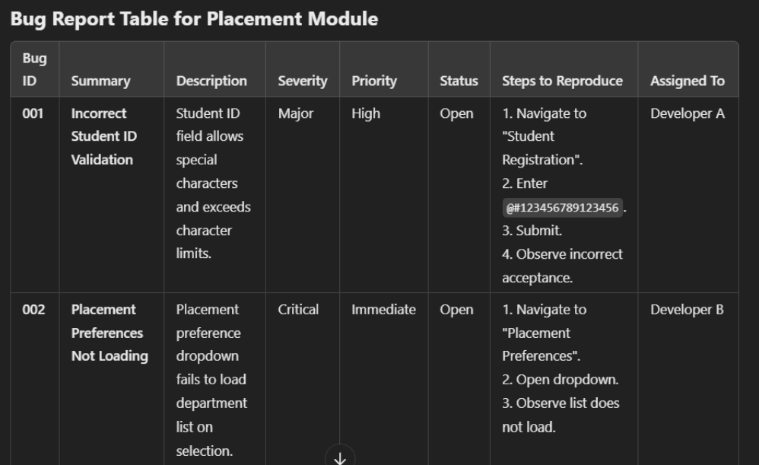
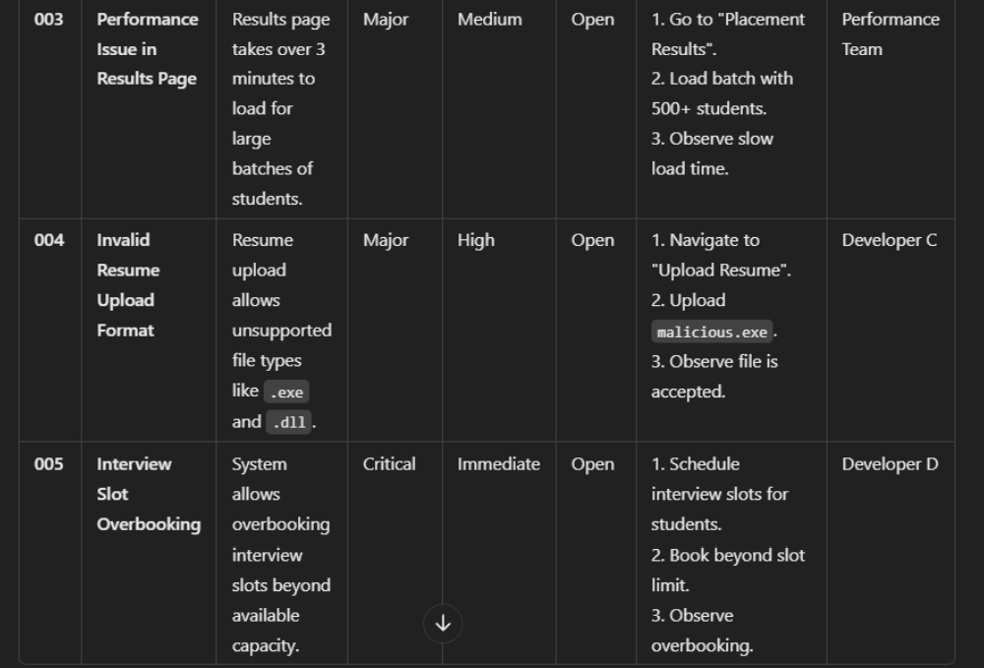

CHAPTER 7
RESULT AND DISCUSSION

Impact and Benefits of the Placement Module
The Placement Module was designed to streamline and automate the recruitment process, providing substantial improvements across various dimensions of the system. By integrating multiple advanced features, the module aimed to reduce manual effort, enhance user experiences, simplify data management, and increase transparency for both students and recruiters. The system, developed with technologies such as HTML, CSS, JavaScript, Bootstrap, SQL, and REST APIs, delivered considerable improvements that contributed to more efficient recruitment processes. Below, we explore the specific advantages and impacts of the Placement Module.
1. Improved Efficiency
One of the key outcomes of the Placement Module was a substantial improvement in operational efficiency. Prior to the module's implementation, the placement process was largely manual, requiring significant time and effort for job postings, student applications, and interview scheduling. Coordinators often faced challenges in managing these tasks efficiently, leading to delays and administrative bottlenecks.
The Placement Module minimized the need for manual intervention by automating several key aspects of the recruitment process. Job advertisements could now be posted directly to the platform, making it easy for recruiters to reach potential candidates without needing to rely on traditional channels like email or phone calls. Similarly, students could submit their applications through the system, with the platform automatically processing and categorizing their submissions. Interview scheduling was also automated, allowing recruiters to select available time slots and automatically notifying students of their interview schedules.
As a result, coordinators experienced a significant reduction in processing time, as repetitive administrative tasks were handled automatically. With less time spent on manual processes, the team could focus on higher-level responsibilities such as candidate selection, communication, and follow-up. Additionally, better organization was achieved by centralizing the entire recruitment process in one platform, which helped to ensure that all stakeholders had access to up-to-date information at any given moment.

2. Improved User Experience
The Placement Module was designed with a strong focus on user experience, ensuring that both students and recruiters could interact with the system easily and efficiently. The user interface was crafted using HTML, CSS, JavaScript, and Bootstrap to create a responsive, clean, and intuitive design. This ensured that the system was not only visually appealing but also functional across various devices and screen sizes, such as smartphones, tablets, and desktops.
For students, the system provided a user-friendly interface that allowed them to quickly navigate through job postings, submit applications, and track the status of their applications in real time. The responsive design ensured that students could access the platform from any device, making it convenient for them to apply for jobs and stay updated on application progress, regardless of where they were or when they wanted to engage with the system.
Recruiters also benefited from the intuitive interface, which allowed them to easily manage job postings, review student applications, and schedule interviews. The user experience was further enhanced by features like real-time messaging and auto-tracking, which fostered seamless communication between students and recruiters. Real-time messaging allowed recruiters and students to interact directly through the platform, facilitating swift clarification of queries and providing immediate feedback. Auto-tracking enabled both students and recruiters to keep track of important milestones, such as application submission, interview scheduling, and final selection status. This feature ensured that all parties remained engaged and informed throughout the recruitment process.

3. Improved Data Management
Effective data management was one of the core advantages of the Placement Module. Prior to the system's implementation, managing student profiles, job postings, and application statuses was often cumbersome and error-prone, requiring manual entries and complicated file storage systems. With the Placement Module, all of this data was centralized in a secure SQL database, ensuring that it was well-organized, easily accessible, and securely stored.
The centralized database provided a single point of access for both students and recruiters to retrieve the necessary information. Students could easily access their profiles, update their resumes, and track their application statuses, while recruiters could view detailed student profiles, application materials, and interview schedules in one place. This streamlined approach helped avoid errors and redundancies, ensuring that all data was up-to-date and accurate.
Furthermore, the use of REST APIs enabled smooth data transfer between different parts of the system. These APIs allowed the Placement Module to communicate with external services and databases, facilitating the exchange of information between the student-facing interface and the recruiter interface. The efficient data transfer made the system more dependable, as it reduced the likelihood of data inconsistencies and ensured that users had access to accurate, real-time information.
4. Greater Transparency
Transparency in the recruitment process is essential for maintaining trust and confidence among both students and recruiters. The Placement Module introduced greater transparency by providing real-time updates on the application process, allowing students and recruiters to track the status of their applications at every stage.
Students could easily see whether their applications had been received, reviewed, shortlisted, or rejected, eliminating any ambiguity and uncertainty about the recruitment process. This visibility helped students stay informed and empowered, reducing the stress of waiting for updates or fearing that their applications had been overlooked.
Recruiters also benefited from this transparency, as they had access to clear, organized information about each candidate’s progress in the hiring process. This allowed for more efficient decision-making and a clearer understanding of where each candidate stood in the process. Furthermore, secure authentication processes ensured that only authorized users had access to sensitive data, safeguarding the privacy of student profiles and recruitment details.

5. Simplified Recruitment Process
Overall, the Placement Module was designed to simplify the recruitment process for all parties involved. By automating key functions such as job posting, application submission, and interview scheduling, the system significantly reduced the workload for coordinators, recruiters, and students alike. The system provided a centralized, user-friendly platform that improved communication, data management, and transparency, ultimately resulting in a smoother and more effective recruitment process.
The streamlined operations helped both students and recruiters save valuable time, allowing students to focus on finding the best opportunities and recruiters to concentrate on selecting the most qualified candidates. By automating routine tasks and improving engagement through real-time updates and messaging, the Placement Module effectively enhanced user satisfaction, leading to better outcomes for all stakeholders.
In conclusion, the Placement Module successfully addressed several pain points in the recruitment process, delivering significant improvements in efficiency, user experience, data management, transparency, and overall process simplicity. The system's ability to automate routine tasks and facilitate smoother communication has not only made the recruitment process more efficient but also enhanced the experience for both students and recruiters, ultimately contributing to the success of the placement process.

CHAPTER 8
CONCLUSION AND FUTURE SCOPE
The designing and the implementation of new functionalities in the placement module have significantly improved the overall functionality and user experience for both the students and the recruitment coordinators. Some added functionalities include:

1. Probability of Selection: It gives pupils a facts-and-figures projection of their selections into an organization, which empowers informed decision making and widens their scope of development. Concentrating on such earlier test scores, performance on coding platforms- LeetCode, HackerRank, and even interview results- this model really opens their possibilities by reflecting on their strengths and weakness related to the company's expectations.
2. Resource Sharing: We create a lot of environmental diversity, especially among the selected students who get a chance to share resources, preparation strategies, and insights with other members. This will not only help students access relevant and tested materials but also involves mentorship and peer support that will enhance the confidence and preparedness of future candidates.
3. Tracking for recruitment Stage: Many times, students are confused and vague during the recruitment stages. It offers clear visibility and transparency wherein every student must undergo registration, aptitude test, coding test, interview, etc. Real time updates and information make time and preparation for each stage significantly easier, which in turn helps in eliminating stress and confusion.

Together, these tools allow students to be more prepared in advance of and during the placement process with more ease, confidence, and preparedness. The module also helps recruitment coordinators and companies by making communication smoother and coordinating work better in the recruitment drive.

Future Scope
The current placement module is a great foundation for managing recruitment, but with many scopes of improvement and growth areas:

1. AI-Powered Personalized Recommendations: Future release of the module could be embedded with AI-driven personalize feedback for the student based on a percentage likelihood of being selected. The system may recommend a course or certification or practice questions that would raise that student's chances of getting selected within that company.
2. Efficient Resource Sharing through Organized Content: What we would have is a content library where people can share resources that not only exist within a firm but also by type of skill-learning (coding, aptitude, communication)-and, again, levels of experience (beginner, intermediate, advanced). This way, the next candidate could easily sort and search for needed resources.
3. Virtual mock interview can be integrated: Another area of improvement could be virtual mock interviews. Students could go through AI simulated technical and HR interviews according to the requirements of the company so that they could hone their skills and get real-time feedback from the authorities regarding their performance.
4. Inter-Institution Interaction: This module can be stretched to interact with many institutions, providing the students with greater access to a larger reservoir of combined resources and knowledge base. It would thus create a broader learning and preparation network across institutions.
5. Advanced Analytics in Career Services: Advanced analytics and dashboards can be provided for career services and recruiters to enable them to make better decisions. Recruitment trends, student performance, areas where the students require extra training or any additional resources, will all be reflected, which may then lead to more effective placements and better-prepared candidates.
REFERENCES
[1] Punitha Nicholine J, Lakshmi Priya B, Ilakkiya S, Kartheeswari M, Kethrin Malar D, “Placement Management System”, International Journal of Progressive Research In Engineering Management And Science (IJPREMS) Vol. 03, Issue 04, April 2023, pp: 120-124
[2] Ajeena Sunny, Aneena Felix, Angelin Saji, Christina Sebastian, Praseetha V.M. “Placement Management System for Campus Recruitment”, International Journal of Innovative Science and Research Technology Volume 5, Issue 5, May – 2020
[3] Adarsha S.P, L. Manisha Rani, D. Indu, J.N S Gopika, M. Harini, S. Sohail, “Placement Management System for Campus Recruitment”, International Journal of Research Publication and Reviews”, Vol 3, no 6, pp 2520-2523, June 2022
[4] By Stijn Baert, Brecht Neyt, Thomas Siedler, Ilse Tobback, Dieter Verhaest, “Student internships and employment opportunities after graduation: A field experiment”, Economics of Education Review Volume 83, August 2021, 102141
[5] Alfiya Banu, Dr. Manju Bargavi S. K, “A Research on Placement Management System” International Journal for Research in Applied Science & Engineering Technology (IJRASET) Volume 10 Issue IV Apr 2022

RESEARCH PAPER
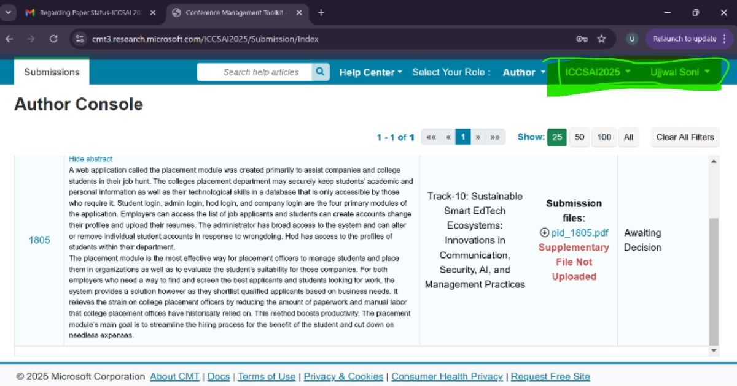

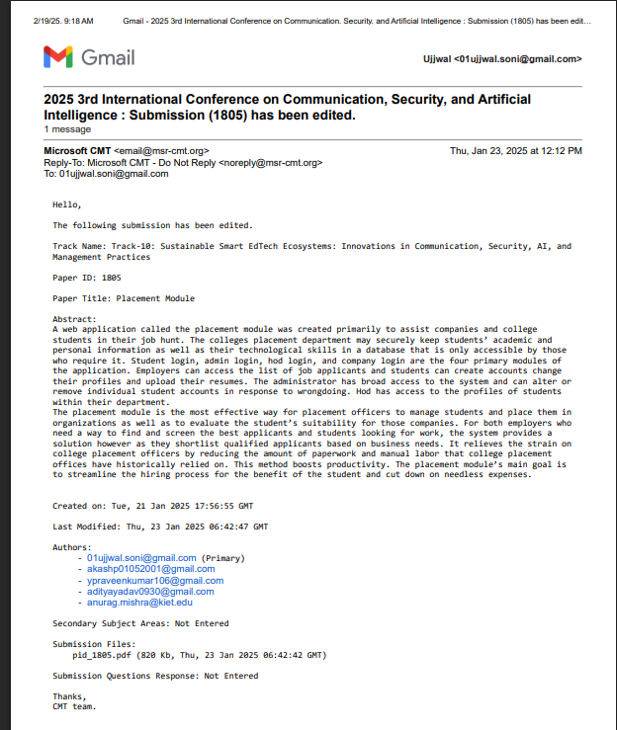

PATENT DRAFT
